TI 23 – 06 Technology Example – Fugro QuickVision ROV Augmented Reality System
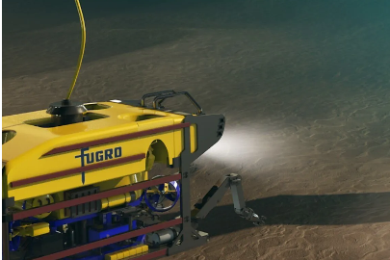

Fugro Remote sensing technology
QuickVision® – this solution involves a coded pattern which is stuck onto the subsea asset or foundation. The smart subsea camera is operated from an ROV. The smart camera combined with a range of sensors typically available on an ROV, tracks the coded pattern to measure the position, heading and attitude of the subsea asset in real time. Using QuickVision® removes the need for any physical sensor to be attached to the asset, resulting in significant risk mitigation and time reduction.

Link to Vendors website for further information:
Fugro positioning and construction support | Fugro

